 I don't understand.
I have a problem.

I can't see the board.  I don't have  Can I borrow ?

Can you help me, please?
 What is the homework?
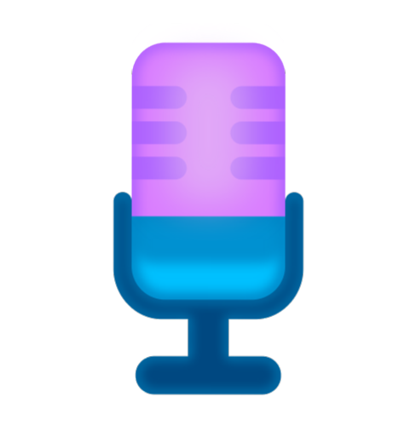 Can you speak louder, please?
Can you speak more slowly, please? Can you repeat, please?
 What page are we on?

What do we have to do now?

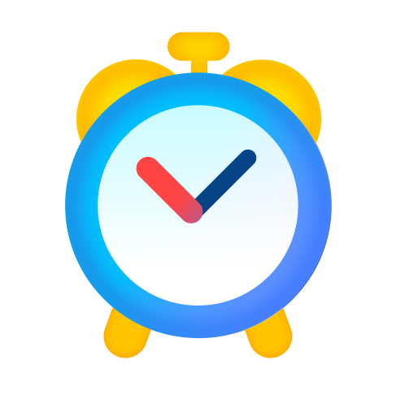

I'm ready.
Can I answer the question?
How do you say-- in English? How do you spell ?

Wait a minute, please.
What is mean?
? What does the word

 Sorry, I did not hear that. 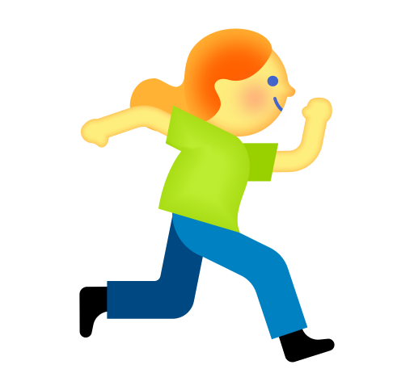 Can I come in?
 I'm sorry I'm late.
 Can I go to the restroom?  Can I change seats?
 Can you switch on/off the lights?

Can I open/close the window?

Asking for an opinion

- What do you think about...?
- What are your thoughts on all of this?
- How do you feel about that?
- Do you agree?

Agreeing

- I share your point of view.
- I think/believe so, too.
- I have come to the same conclusion.
- I hold the same opinion.
- I have no objection whatsoever.
- I see it that way too.

Expressing an opinion
- In my opinion/view....
- From my point of view...
- If you ask me...
- As far as I'm concerned....
- It seems to me that....
- Well, I'd say...

Disagreeing

- I see what you mean, but...
- You may be right, but...
- I respect your point but from my perspective...
- I don't see it that way.
- I'm not sure I agree with you on...

To clarify something

What makes you think that?
Can you explain what you mean by...? Let me put it this/another way....
What I actually meant was....
The point I'm trying to make is...
In other words, you think...
If I understand you correctly, your idea is...

Expressing understanding

You have a point there. I see what you mean.
That's an interesting example.
Now I understand your perspective.

To tell about group work
My partner(s), ... and I discussed...
My partner(s) and I decided that/agreed on...
One example my partner offered was...

Reporting a problem

- I can't hear you. You're on mute/ your mic is off.
- I'm sorry, you're breaking up. Could you say that one more time?
- The connection is bad. Can you say that again?
- The link is not working.
- Could you resend the link, please?

Giving an answer

- Just a moment, please.
- May I have some time to think?
- I'm ready. Can I answer?
- Can I answer the question?

- I can't see your screen/the presentation.
- Sorry, my internet is really slow today.
- Can you hear/see me now?
- How is that? Any better?
- Sorry, I'm having a sound issue.
- I need to turn my camera/mic off for a moment, I'll be rignt back.

Vocabulary

- What does the word mean?
- Can you use this word in a sentence?
- What is another word for ?

- Is this correct?
- How do you say
in English?

- I'm not sure, but can I guess?

Asking for help

- Can you help me, please?
- Will you give me a clue?
- Can you help me figure this out?
- I have a question about
- I don't quite understand what you mean by

Instructions

- What do we have to do now?
- Do we have to write this down?
- What is the homework?
- When is the assignment due?
- What page are we on?
- How do you spell ?

- Would you give us an example?
- What is the difference between --
and ?
- Can you explain it once more, please?

- Can you speak louder/more slowly, please?
- Sorry, I did not catch the last part/part about . Could you repeat that, please?

Asking for help

  - Can you help me, please?
  - Will you give me a clue?
  - Can you help me figure this out?
  - I have a question about
  - I don't quite understand what you mean by
  - Would you give us an example?
  - What is the difference between and ?
  - Can you explain it once more, please?

Giving an answer

  - Just a moment, please.
  - May I have some time to think?
  - I'm ready. Can I answer?

Vocabulary

  - What does the word
  - Can you use this word in a sentence?

mean?

  - Can I answer the question?
  - What is another word for ?

  - Is this correct?
  - I'm not sure, but can I guess?

Instructions
  - How do you say
  - How do you spell

Other requests
in English?

?

  - What do we have to do now?
  - Do we have to write this down?
  - Can you speak louder/more slowly, please?
  - Sorry, I did not catch the last part/part about . Could you repeat that, please?
  - What page are we on?
  - What is the homework?
  - When is the assignment due?
  - Sorry I'm late. Can I come in?
  - Can I go to the bathroom?
  - Can I change seats?
  - I can't see the board, can you step aside?
  - Can I switch on/off the lights?
  - Can I open/close the window?
  - Can I borrow ?
  - Excuse me, can I talk to you for a minute?

